Refworks training workbook
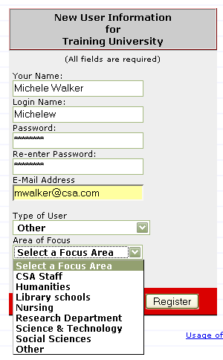

- Set-up an account.
  - Point your browser to www.refworks.com/refworks (or click through from your institution’s web page link)
  - Click on Sign up for a New Account
  - Fill in the form
Focus groups and user types can be defined to suit your institution
  - Click on Register
  - Congratulations you now have a RefWorks account.
  - Now login to RefWorks using your credentials.

- Direct Import from CSA Illumina (or insert one of these databases, to which your institution subscribes)
  - In a separate browser window, open the Database
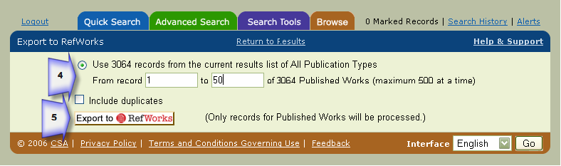
  - Search for ‘assertive*’ in abstracts in Advanced Search tab
  - From Result list, click on RefWorks
  - Choose from record 1-50
  - Click again on Export to RefWorks
  - The 50 references will be imported into your database

- Import data from Web of Knowledge
- In a separate browser window open Web of knowledge and carry out a simple search.
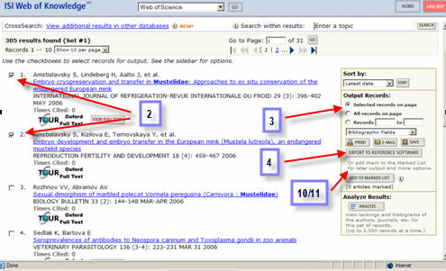
- From your search results, select items to save by clicking in the checkbox to the left of the appropriate citations.
- On the right of your screen, choose to export either : Selected records on page ; All records on page ; or a Record range, using the to and from boxes.
- On the drop down menu below choose either : Bibliographic ; Bibliographic + abstract ; Full record ; or Full record + Cited references, and click the Save button.
- Check the first option: Field Tagged (plain text) -Import into a reference management tool, and select Save to disk option.

- In RefWorks, select References/Import from the toolbar.
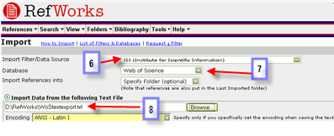
- Select ISI (Institute for Scientific Information) as the data source and Web of Science as the database.
- Browse to find the text file you saved to your computer and click on Open
- Click Import. Your records should appear in the Last Imported Folder.

If you select records from different pages, you will need to follow the instructions below:
- From your search results, select the items you wish to save by clicking in the checkbox to the left of the appropriate citations.
- Submit each page’s selections
- When your search and selection is complete, click the Marked List button, which appears once you have marked and submitted items.
- Choose the service you used from the Display Marked list drop down edit menu
- In the section called Step 1. Select the fields to include in the output: Select the fields that you want to include in your database.
- Click the Save to File button. You should leave the option as Field Tagged. Select Text as the Save As file type. Choose the Save to Disk option and click on OK.
- Continue as for 5-8 above.

- Import direct from Google Scholar (http://scholar.google.com)
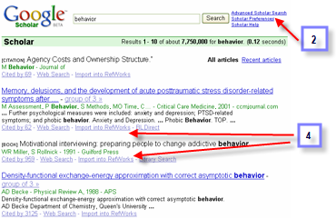
  - Make sure cookies are enabled to allow setting of preferences in Google Scholar
  - From the GS search screen click on Scholar preferences
  - At the bottom of the screen, in ‘Show links to import citations into’, select RefWorks
  - Search results now display an ‘Export to RefWorks’ link.

NOTE: this needs to be done on a one by one basis. GS does not have facility to mark records

NOTE: consistent data such as title, author, year, etc may not exist in your results; the only thing they may display is the URL. If the metadata exist, it will import into RefWorks.
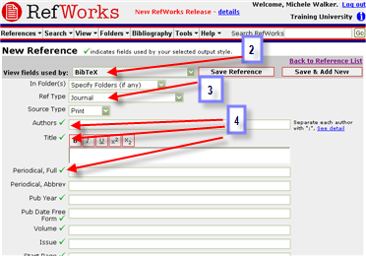
- Add new reference manually
  - Click References | Add a reference
  - Select BibTex standard in AccuCite
  - Select Journal as reference type
  - Enter details in all field marked with ✓
(ie fields required for correct citation
in this output style)
  - Save reference, or Save & Add New to continue adding more references

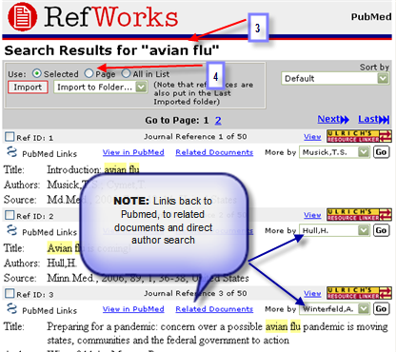
- Search z39.50 Database (PubMed)
  - Click on Search | Online databases and Catalogues
  - Select Pubmed
  - Search for ‘avian flu’ as quick search
  - Import all on ‘Page’
  - Close the Search results page and return to RefWorks

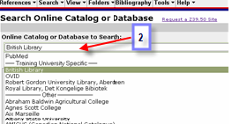
- Search a library Catalogue.
  - Click on Search | Online Catalog or Database
  - Choose a library catalogue from the alphabetical drop down list (your own, or a National Library?)
  - Do an Advanced Search for the Descriptor: Influenza
  - Import ‘All in the list’
  - Close the Search results and return to RefWorks

- Search RSS feeds
  - Click on Search | RSS Feeds
  - Enter the URL for an RSS feed (eg http://www.nature.com/nature/current_issue/rss for Nature; http://www.newstatesman.co.uk/nsfreetoview.xml for New Statesman
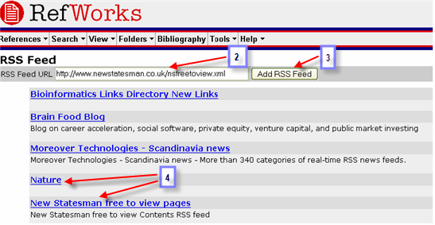
Or type <journal title> and RSS into Google, and if you find a feed either select and copy the displayed URL – or right click on the RSS or XML orange button, and select Copy Shortcut to paste as RSS feed URL)
  - Click Add RSS Feed
  - Once the feed has been added, click on feed title
  - A separate window will open with updated feeds
  - Select a few you are interested in
  - Click Import to pull them into RefWorks
  - From RefWorks you can now click live link to get to fulltext from Reference

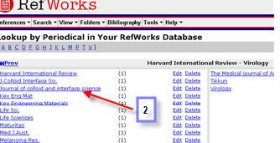
- Searching your RefWorks database using the Lookup Function
  - Click on Search | Lookup by Periodicals
  - Go to a journal title and click on the link,
- to see all records in your RefWorks account that are published in this journal

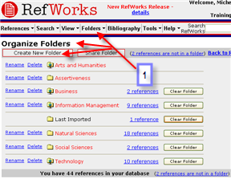
- Creating folders and moving information
  - Click on Folders | Organize Folder
  - Click on Create New Folder
  - Name it Viruses and click on OK
  - Create another folder called Assertiveness
  - In Quick Search, search for flu
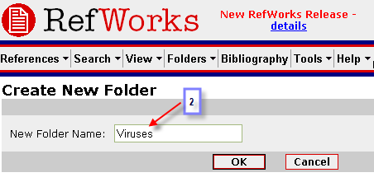
  - Select all in list
  - Add to the folder Viruses
  - Click on Search | Advanced
  - Search in the abstracts for ‘assertiveness’ and publication year ‘2005’
  - Import ‘All in the list’ direct to the Assertiveness folder

- Sort your references by journal name
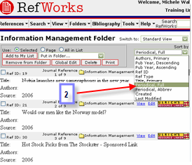
  - Click on View | Folder and choose Viruses
  - From drop down box Sort By Periodical Full
( If you can not see the box on the right hand side of the screen you will need to hide the search tool, by clicking on Hide in the Search tools section)

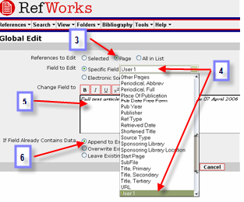
- Do a global edit
  - Click on View | Folder and choose Assertiveness
  - Click on Global edit
  - Select to edit references from ‘Page’
  - Choose to change the user defined field.
  - Type in : - Full text article requested from the library on the 28 July 2026
  - Select ‘Append to Existing data’
  - Click on OK.

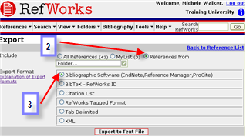
- Exporting your references
  - Click on References | Export
  - Select to export the content of the folder Viruses
  - Select Bibliographic Software format
  - Click on Export to text file
  - Save to text file in format required for import to Endnote, Procite etc

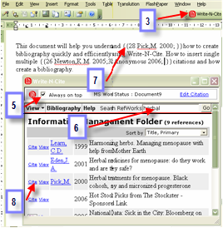
- Create a Bibliography with Write n Cite
Word window
  - Log out of RefWorks.
  - Open Word and type the following text:

This document will help you understand how to create a bibliography quickly and efficiently using Write-N-Cite. How to insert single and multiple citations and how to create a bibliography.

  - Click the Write-n-cite plug in on the toolbar or the desktop
  - Login to your RefWorks database.
  - Tick the ‘Always on top’ radio button
  - Do a quick search for ‘flu’
  - In Word document, place your cursor in the text, where you want to insert the citation
  - Back in the Write n Cite list, click on Cite next to the record that you want to cite
Write n Cite Window
  - Repeat this in a few different places. Try duplicate entries in the same citation.
  - Save your document as RWcite.
Sample ‘final document ‘– with properly formatted citations and bibliography

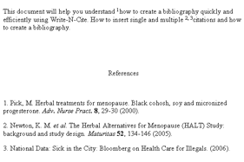
  - Back on the Write n Cite Window, click on Bibliography and choose Nature output style
  - This will create a second document called FinalRWcite. Save as RWCiteNature
  - Repeat the bibliography creation using a different output style. Another FinalRWcite document will be created with the new style. Save as RWCite<Style>.

NOTE: remember to always work and edit in the original work document (though you can save as many final documents, at various stages and in as many styles as you wish)

- Create a Bibliography without Write-N-Cite
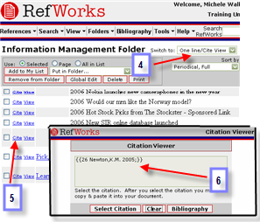
  - Open Word and type the following text:
This document will help you understand how to create a bibliography quickly and efficiently when Write-N-Cite plug in is not available. (This can happen when working from machines other than your own or off campus).

  - Login to RefWorks
  - Do a quick search for “assertiveness”
  - Choose the One line / Cite view
  - Choose a reference and click on Cite
  - A box will open with the citation number properly formatted for Write n Cite. Select everything in the window and save to clipboard
  - Place your cursor where you want the citation to appear in your text and paste this citation into your word document
  - Repeat the previous steps with another citation, or multiple citations, placing them elsewhere in the text
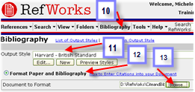
  - Close and save your document as RWtraining2.
  - In RefWorks click on Bibliography
  - Choose Harvard British Standard
  - Tick Format Paper and Bibliography
  - Browse to your Word file as the Document to Format
  - Click on Create Bibliography
  - You now have a second document, with proper citations and formatted bibliography. Save as RWFinalHarvard

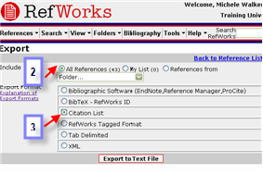
- Add citations while working offline
  - (Before you go) In RefWorks go to References | Export
  - Select to export: All references
  - Select Citation List format
  - Click export to text file
  - Save file on laptop, to USB and/or print out
  - (While away) Refer to this list when typing working documents, and add citations where needed in format {{refID}}e.g.
This document will help you understand how to create citations {{4}} quickly and efficiently {{23; 3}} when the internet is not available
  - Save working document
  - When back to internet access, open RefWorks and proceed, as above with bibliography, to create final document

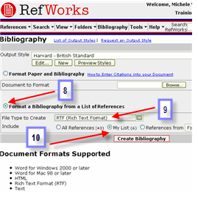
- Create a list of references in preferred Output Style
  - In RefWorks, click View | Folder ! Viruses
  - Select one or two references
  - Click on Add to my list
  - Click on Folders | View | Assertiveness
  - Select two or three references
  - Click on Add to my list
  - Click Bibliography
  - Tick Format a Bibliography from a List of References radio button
  - Select RTF (Rich Text Format) as File Type to Create
  - Tick My List
  - Click on Create Bibliography
A list of properly formatted references will be created in an RTF file for you to save, print, email as required.
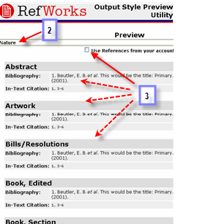
- Edit/Create Output style
  - Click Bibliography
  - Select an output style you think may be close to your preferred format
  - Preview style (untick Use Your References button, to review style for all reference types)

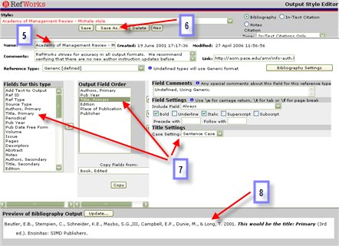
  - Click Edit box, beside or under Output style selection box
  - Rename
  - Click ‘Save as’ to mark it as your own (title will appear in the list in red)
  - Make any changes to the format you require
  - Preview of how the citation looks displays at bottom of screen
  - Save.
(Refer to Using the Output Style Editor, in the Help file, for assistance)

- Share Output Styles with colleagues
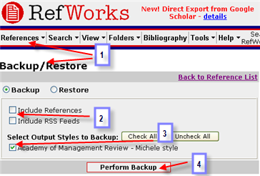
  - Clicking References | Backup/Restore,
  - De-select References and RSS feeds
  - Select output style/s you wish to share.
  - Click to Perform Backup
  - Pass the file created to colleagues, who should then, in their own RefWorks database:
  - Click on References |Backup/Restore
  - Browse to and Select the file
  - Select Output style/s and click ‘Restore’ to add the style/s (still in red) to their list.
  - To make it site wide, pass the file to the Administrator who can add it to the Master Admin account.
Once site wide the style will appear to everyone at that institution in black

Alternatively (for ‘official’ styles not already listed) :
- Click on Bibliography
- Click on ‘Request an Output Style’
- Fill in style format details, or link to journal web page
- Submit to RefWorks, who will create the style for you and add it to the RefWorks list of Output styles.

